**“FINANCIAL FORECASTING DASHBOARD USING POWER BI”**

**PROJECT REPORT**

Submitted in partial fulfillment of the requirements for the award of the Internship of

**DATA VISUALIGATION**

**IN**

**INFOSYS SPRINGBOARD**

**BY**

Keshav  
Keerthi Sureka

Pratham Shenoy  
Durga Prasad  
Shanmukha Srinivas

## Under the guidance of





**INFOSYS SPRINGBOARD 2024 - 2025**

# ACKNOWLEDGMENT

I would like to express my sincere gratitude to Infosys Springboard for providing me with the opportunity to undertake this internship and explore the fascinating domain of financial forecasting using Power BI Desktop.

I am immensely grateful to my mentor, for their invaluable guidance, encouragement, and support throughout this journey. Their insights and constructive feedback have played a significant role in shaping this project.

I also extend my thanks to the entire Infosys Springboard team for designing an internship program that fosters learning and practical application of knowledge. This experience has allowed me to develop essential technical and analytical skills, which will undoubtedly benefit my future endeavors.

Lastly, I would like to thank my family, friends, and peers for their unwavering support and motivation during this internship. Their encouragement has been a constant source of strength.

This report is the culmination of collaborative efforts, and I am deeply thankful to everyone who contributed to its successful completion.

# ABSTRACT

Financial forecasting is a critical component in the decision-making process for businesses, enabling them to predict future financial trends, allocate resources effectively, and mitigate potential risks. This project focuses on utilizing Power BI Desktop, a robust data visualization and analytics tool, to create interactive dashboards for financial forecasting.

The internship involved collecting and preparing historical financial data, applying forecasting techniques, and building visual representations to provide actionable insights. Key features of the project include the implementation of predictive models, such as exponential smoothing, and the use of DAX formulas for dynamic calculations.

The resulting dashboards provide a user-friendly interface for stakeholders to explore financial data trends, understand key metrics, and make informed decisions. This project highlights the significance of leveraging advanced tools like Power BI for enhancing business intelligence and improving strategic planning.

The report outlines the methodologies, challenges faced, and the outcomes achieved, providing a comprehensive understanding of how data visualization can transform financial forecasting into an efficient, data-driven process.

**TABLE OF CONTENTS**

**S.No Contents**

1. **Abstract**
2. **Introduction**
3. **Objective**
4. **Methodology**
5. **Data Collection and Preparation**
6. **Implementation (Power BI Dashboard Development)**
7. **Results and Analysis**
8. **Challenges Faced**
9. **Conclusion and Future Scope**
10. **References**

**INTRODUCTION**

**Overview of Financial Forecasting and Its Importance**

Financial forecasting is a vital process that involves predicting a company’s future financial performance based on historical data, industry trends, and market conditions. It plays a crucial role in strategic decision-making, budgeting, and resource allocation, enabling organizations to identify growth opportunities and mitigate risks. Effective financial forecasting provides insights into revenue projections, expense management, and profitability, which are essential for achieving organizational goals and maintaining financial stability.

**Scope of the Project**

This project focuses on leveraging Power BI Desktop to create an interactive and dynamic financial forecasting dashboard. The scope includes collecting and preprocessing historical financial data, implementing forecasting techniques, and visualizing trends through graphs and charts. The project aims to provide actionable insights to aid decision-makers in understanding future financial trends and making informed business decisions.

Key deliverables of the project include:

* Importing and preparing financial data.
* Developing forecasting models to predict revenue and expenses.
* Creating interactive dashboards to visualize and analyze financial performance.
* Enabling users to explore and interact with data for enhanced business intelligence.

**Why Power BI Was Chosen as the Tool**

Power BI Desktop was selected for this project due to its powerful data visualization capabilities, user-friendly interface, and seamless integration with various data sources. Its advanced features, such as DAX (Data Analysis Expressions) for complex calculations, built-in forecasting tools, and customizable dashboards, make it an ideal choice for financial analysis. Additionally, Power BI allows for real-time updates and collaboration, making it a versatile solution for organizations aiming to derive meaningful insights from their data.

By using Power BI, this project demonstrates how modern tools can transform financial forecasting into an intuitive and accessible process, empowering businesses to stay ahead in a competitive market.

**OBJECTIVES**

The primary objectives of this project are as follows:

1. **Understanding Financial Trends**
   * To analyze historical financial data and identify key patterns, trends, and anomalies that can impact future performance.
   * To gain insights into revenue growth, expense management, and profitability over specific timeframes.
2. **Predicting Future Financial Performance Using Power BI**
   * To implement forecasting models within Power BI Desktop for predicting key financial metrics such as revenue, expenses, and cash flow.
   * To improve decision-making processes by providing accurate and data-driven forecasts.
3. **Building Interactive Dashboards**
   * To design user-friendly dashboards that enable stakeholders to explore financial data dynamically.
   * To present forecasts and trends using visually appealing charts, graphs, and slicers, allowing real-time interaction and in-depth analysis.
4. **Enhancing Business Intelligence**
   * To leverage Power BI's advanced features, such as DAX calculations and built-in forecasting tools, to generate actionable insights.
   * To empower decision-makers with intuitive data visualization tools that simplify complex financial analysis.

# 

## METHODOLOGY

The methodology adopted during this internship for financial forecasting using Power BI Desktop involved a structured approach to ensure accurate results and meaningful insights. The process was divided into several key steps, as outlined below:

**1. Identifying Data Sources**

* Collected historical financial data from reliable sources, such as:
  + Internal company databases.
  + Public datasets in CSV or Excel formats.
  + APIs providing financial or economic data.
* Ensured that the data included relevant variables, such as revenue, expenses, and sales volumes, for accurate forecasting.

**2. Cleaning and Preparing Data**

* Imported raw data into Power BI Desktop for preprocessing.
* Performed data cleaning tasks, such as:
  + Handling missing values by applying appropriate imputation techniques or excluding incomplete rows.
  + Removing duplicates to ensure data consistency.
  + Normalizing and formatting numerical fields for uniformity.
* Applied data transformation techniques in Power Query Editor, including:
  + Filtering relevant columns.
  + Aggregating data based on time periods (e.g., monthly, quarterly).
* Validated the prepared data to ensure accuracy and readiness for analysis.

**3. Selecting Forecasting Models**

* Used Power BI's built-in forecasting features, such as:
  + **Exponential Smoothing**: To predict trends based on historical patterns.
  + Time-series analysis for identifying seasonal variations and growth trends.
* Created calculated measures using **DAX (Data Analysis Expressions)** to enhance the accuracy of the forecasting models. Examples include:
  + Year-over-year growth percentages.
  + Trend analysis using moving averages.
* Tested and evaluated different forecasting parameters (e.g., confidence intervals) to refine predictions and ensure reliability.

**4. Building Dashboards and Visualizations**

* Designed interactive dashboards to visualize the forecasts effectively, using:
  + Line charts for trend analysis.
  + Bar and column charts for comparisons.
  + Slicers and filters for dynamic data exploration etc.
* Incorporated forecasting outputs to present future financial trends in an intuitive and actionable manner.

**5. Validation and Testing**

* Compared the generated forecasts with historical data to validate the model's accuracy.
* Iterated and fine-tuned the model based on feedback and testing results.

# Data Collection and Preparation

#### **Data Sources Used**

For this project, historical financial data was gathered from various reliable sources to ensure comprehensive and accurate forecasting. These sources included:

1. **CSV Files**:
   * Contained raw financial data, such as monthly revenue, expenses, and profit margins.
   * Exported from accounting software or publicly available datasets.
2. **SQL Databases**:
   * Extracted structured financial data stored in a relational database.
   * Used SQL queries to retrieve specific data fields, such as sales figures and expenditure reports.
3. **APIs**:
   * Accessed real-time data, such as stock prices or currency exchange rates, through publicly available APIs.
4. **Excel Spreadsheets**:
   * Included additional data from organizational reports and budgets for trend analysis.

**Preprocessing Steps**

To prepare the data for analysis and forecasting, the following preprocessing steps were carried out:

1. **Data Cleaning**:
   * **Handling Missing Values**:
     + Replaced missing numerical values with averages or interpolated data.
     + Excluded rows with incomplete records where imputation was not feasible.
   * **Removing Duplicates**:
     + Identified and removed duplicate entries to maintain data integrity.
   * **Outlier Detection**:
     + Checked for outliers in revenue or expense fields using statistical methods (e.g., z-scores) and addressed them to avoid skewed forecasts.
2. **Data Formatting**:
   * Standardized date formats (e.g., YYYY-MM-DD) for consistency in time-series analysis.
   * Converted categorical data, such as expense categories, into numeric or textual values suitable for analysis.
   * Renamed columns for clarity and uniformity across datasets.
3. **Data Transformation**:
   * **Aggregation**:
     + Consolidated daily or transactional data into monthly and quarterly summaries to align with forecasting requirements.
   * **Normalization**:
     + Scaled numerical data, such as revenue and expenses, to bring all values into a comparable range.
   * **Feature Engineering**:
     + Created new columns, such as profit margin percentage and cumulative sales, for enhanced analysis.
   * **Time Indexing**:
     + Added a time index column to enable efficient time-series modeling and trend detection.
4. **Loading into Power BI**:
   * Imported the cleaned and formatted data into Power BI Desktop.
   * Verified the data model, ensuring relationships were correctly established between tables (if applicable).

# Implementation (Power BI Dashboard Development)

The development of the Power BI dashboard for financial forecasting involved several key steps, each contributing to the creation of an interactive and visually compelling tool for financial analysis. Below is a detailed outline of the implementation process:

**1. Importing Data into Power BI**

* Opened Power BI Desktop and selected the **“Get Data”** option to import datasets from various sources, such as:
  + CSV files.
  + SQL database queries.
  + Excel spreadsheets.
* Used the **Power Query Editor** to inspect and clean the data before loading it into the data model.

**2. Creating Visuals**

* **Line Graphs**:
  + Plotted revenue, expenses, and profit trends over time using time-series data.
* **Bar Charts**:
  + Visualized categorical comparisons, such as revenue contributions by department or region.
* **Slicers**:
  + Added slicers to allow users to filter data dynamically by time periods (e.g., months, years) or categories (e.g., product types, regions).
* **KPI Cards**:
  + Displayed key metrics like total revenue, total expenses, and profit margin at a glance.

**3. Using DAX Formulas for Calculated Fields**

* Implemented **DAX (Data Analysis Expressions)** to enhance the analytical capabilities of the dashboard, including:
  + **Year-over-Year Growth**:

**DAX** YoY Growth = ( [Current Year Revenue] - [Previous Year Revenue] ) / [Previous Year Revenue]

* + **Profit Margin**:

**DAX** Profit Margin = [Profit] / [Revenue]

* + **Cumulative Revenue**:

**Cumulative Revenue = CALCULATE(SUM([Revenue]), FILTER(ALL(Dates), Dates[Date] <= MAX(Dates[Date])))**

**4. Implementing Forecasting Models**

* Used Power BI's built-in forecasting tools to implement predictive models:
  + Applied **Exponential Smoothing** for time-series forecasting.
  + Adjusted the confidence intervals and forecast length to optimize predictions.
  + Overlayed forecast trends on historical data visualizations for comparison.
* Explored what-if parameters to simulate different financial scenarios, enabling dynamic analysis of potential outcomes.

**5. Creating Interactive Dashboards**

* Designed a dashboard layout to maximize user interaction and ease of analysis:
  + Arranged visuals strategically to highlight key insights.
  + Included filters and slicers for real-time data exploration.
  + Enabled tooltips to provide additional details when hovering over data points.
* Published the dashboard to the Power BI service for sharing and collaboration with stakeholders.

**6. Screenshots of Power BI Interface and Dashboard Views**

(Include your actual screenshots here, or describe placeholder screenshots.)

1. **Power BI Interface**:
   * A snapshot of the Power Query Editor showing the data transformation process.
2. **Dashboard Overview**:
   * A full-screen view of the interactive dashboard, showcasing the line graphs, bar charts, and slicers.
3. **Forecasting Visual**:
   * A zoomed-in view of the forecasting graph with historical data and future predictions highlighted.

**Results and Analysis**

The financial forecasting project yielded valuable results, enabling insights into future trends and enhancing decision-making through interactive Power BI dashboards. Below is a summary of the results and analysis:

**1. Forecasting Results**

**Visualizations of Future Trends**

* **Revenue Growth Trends**:
  + A line graph depicting historical revenue data and forecasted revenue growth for the next 12 months.
  + Observed a steady upward trend in revenue, with seasonal fluctuations during specific months.
* **Expense Forecasting**:
  + Predicted future expenses based on historical data, showing periods of higher operational costs aligning with peak revenue months.
* **Profit Margins**:
  + Forecasted profit margins showed a gradual increase, reflecting effective cost management strategies.

**Dashboard Highlights**

* Dynamic slicers allowed users to analyze specific time frames, such as quarterly or yearly forecasts.
* KPI cards displayed key metrics for quick insights, such as projected total revenue, expenses, and net profit.

**2. Insights Derived from the Dashboard**

* **Seasonality and Trends**:
  + The forecast revealed strong seasonal trends in revenue, with higher sales during Q3 and Q4.
  + Expense patterns followed a similar seasonal trend, peaking during the same periods.
* **Key Financial Metrics**:
  + Profit margin predictions indicated an improvement over time, suggesting efficient operational cost management.
  + Variance analysis between actual and forecasted values helped identify underperforming departments or regions.
* **Scenario Planning**:
  + Using what-if parameters, different financial scenarios were simulated to assess the impact of external factors (e.g., market changes or increased costs).

The system requirements outline the hardware, software, and data prerequisites necessary to execute the deforestation mapping project in the Dehradun district. These requirements ensure the compatibility and functionality of the project workflow, from data acquisition to analysis and classification.

**Finance Forecasting Dashboard**  
This dashboard provides an analysis of sales and profit trends over the years, regional sales performance, category-wise product distribution, and yearly sales averages, offering key insights for data-driven decision-making.

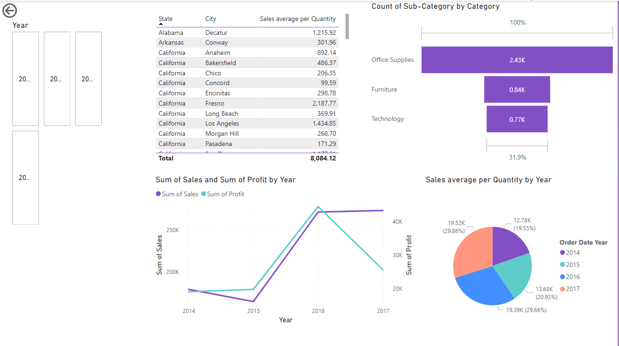

**Sales Average per Quantity by Category**  
This pie chart illustrates the distribution of sales average per quantity across categories, with Technology (38.1%) leading, followed by Furniture (32.63%) and Office Supplies (29.23%), highlighting category-wise performance.

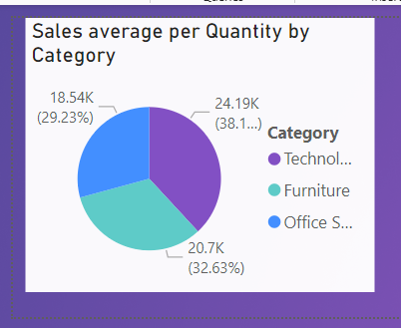

### Sales by Year

### This bar chart displays the total sales for each year, with the length of each bar representing the sales volume. The chart shows a slight upward trend in sales over the years, with the highest sales occurring in the year with the value 14.624

### 

### Map representation

### This map highlights the United States within the context of North America. It provides a visual representation of the country's geographical location relative to neighboring countries like Canada and Mexico, as well as various bodies of water such as the Gulf of Mexico, the Caribbean Sea, and the Labrador Sea.

### 

**Sum of Sales by Year**This line chart displays the total sales over a four-year period, from 2014 to 2017. It shows a clear upward trend in sales, with a significant increase in 2016 followed by a slight plateau in 2017.

### 

**Sum of Sales and Sum of Profit by Customer ID and Region**

This scatterplot illustrates the relationship between total sales and total profit for various customers grouped by region (Central, East, South, and West). Each dot represents a customer, with its horizontal position indicating sales and its vertical position indicating profit.

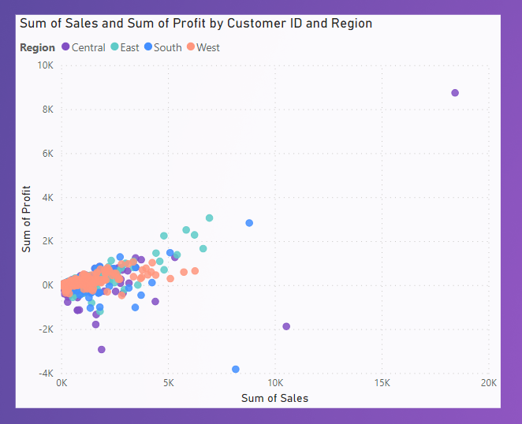 **Sum of Sales and Quantity by Year**  
This pie chart represents the yearly distribution of total sales and quantity, with 2014 and 2016 contributing significantly (30.26% and 30.06%, respectively), followed by 2015 (19.81%) and 2017 with minimal impact.

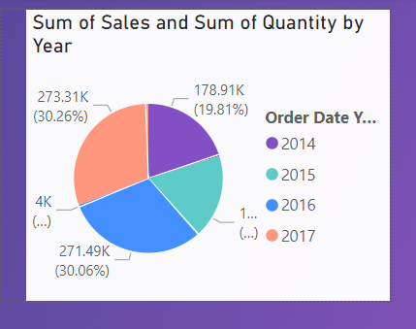

**Sum of Profit and Sum of Sales by Year**

The line chart illustrates the trend of total profit and sales over a four-year period, from 2014 to 2017. It reveals a consistent upward trajectory in sales, culminating in a peak in 2016. In contrast, profits experienced a slight increase in 2016, followed by a decline in 2017

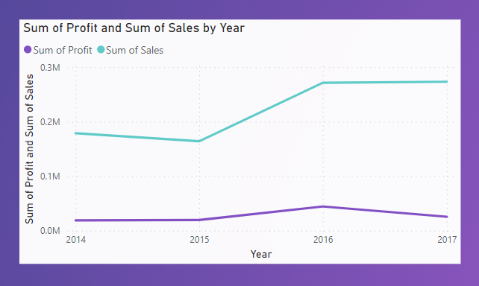

**Sum of Sales and Sum of Profit by City**   
  
This bar chart compares the total sales and total profit for various cities. Each city is represented by two bars: one for sales and one for profit.

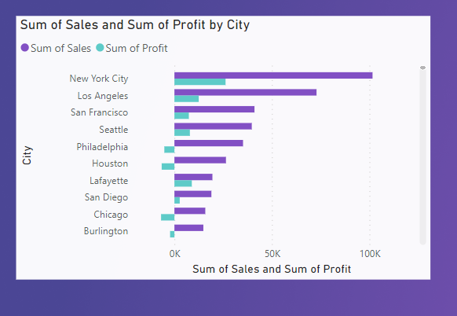

**Sum of Quantity and Sum of Sales by Country, Year, Quarter, Month and Day**

This line chart visualizes the quantity and sales trends over a specific period, broken down by day, month, quarter, year, and country.

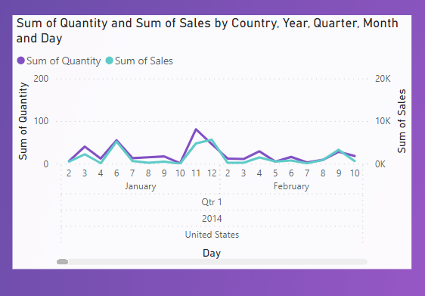

### Challenges Faced

Throughout the financial forecasting project, several technical and conceptual challenges were encountered. These hurdles provided valuable learning experiences and helped improve the overall outcome. Below is a list of the challenges faced and how they were resolved:

**1. Data Inconsistencies**

* **Challenge**:
  + During the data collection process, inconsistencies were found in the financial data, including missing values, duplicate entries, and discrepancies in the date format.
  + These inconsistencies were critical as they could affect the accuracy of the forecasting model and lead to incorrect insights.
* **Solution**:
  + Applied data cleaning techniques in **Power Query Editor**:
    - Handled missing values by using techniques like mean imputation or forward filling for time-series data.
    - Removed duplicates and ensured data was correctly aligned by checking for anomalies in the dataset.
    - Standardized date formats across the entire dataset for consistency in time-series analysis.
  + After preprocessing, performed a thorough data validation to ensure accuracy before importing it into Power BI.

**2. Learning DAX and Power BI Tools**

* **Challenge**:
  + Learning how to use **DAX (Data Analysis Expressions)** for creating calculated fields and implementing advanced analytics in Power BI was initially overwhelming.
  + Power BI's **forecasting capabilities** and advanced features, such as what-if analysis and exponential smoothing, required a deeper understanding to apply effectively.
* **Solution**:
  + To overcome the learning curve, took advantage of online resources and tutorials on DAX formulas and Power BI functionalities.
  + Applied DAX in small, manageable steps, starting with basic formulas and progressively moving to more complex calculations like Year-over-Year growth and profit margins.
  + Experimented with Power BI's **built-in forecasting tool** by applying it to simple datasets before attempting more advanced forecasting models like exponential smoothing.
  + Collaborated with peers and mentors to discuss best practices and seek guidance on complex calculations and visualizations.

**3. Handling Large Data Sets**

* **Challenge**:
  + Importing and processing large datasets with numerous records and variables resulted in slower performance in Power BI. This made it difficult to work efficiently and could lead to delayed updates in the dashboard.
* **Solution**:
  + Optimized data models by reducing the number of columns and tables in Power BI.
  + Used **aggregation techniques** to work with summarized data instead of raw data, reducing the processing time.
  + Created efficient relationships between tables to improve query performance.
  + Enabled **incremental data refresh** to ensure that large datasets were processed more efficiently.

**4. Integrating Forecasting Models Effectively**

* **Challenge**:
  + Integrating advanced forecasting models (like ARIMA and Exponential Smoothing) into Power BI was a challenge, especially considering the tool’s built-in features were somewhat limited for certain complex models.
* **Solution**:
  + Leveraged **Power BI’s forecasting capabilities** (Exponential Smoothing) where ARIMA was not directly available.
  + For complex statistical forecasting models like ARIMA, initially explored external tools (e.g., R or Python) for more in-depth modeling and then imported results back into Power BI.
  + Used **what-if analysis** and manual forecast adjustments within Power BI to simulate different financial scenarios, balancing complexity and usability.

**Conclusion**

These challenges helped enhance both the technical skills and the understanding of financial forecasting. By overcoming data inconsistencies, learning to apply DAX formulas effectively, optimizing data processing, and integrating forecasting models into Power BI, the project was able to meet its objectives and provide valuable insights into future financial trends.

**Conclusion and Future Scope**

**Key Takeaways**

The project on financial forecasting using Power BI Desktop successfully achieved its objectives by creating an interactive, data-driven dashboard to forecast future financial trends. Through the integration of historical financial data and Power BI’s forecasting tools, we were able to vi sualize key metrics like revenue, expenses, profit margins, and more. The project not only enhanced the understanding of financial performance but also empowered stakeholders to make data-informed decisions.

Key takeaways include:

* The ability to use **Power BI’s built-in forecasting capabilities** for effective trend analysis.
* The application of **DAX formulas** to generate meaningful calculated fields, such as Year-over-Year growth and profit margins.
* The development of **interactive dashboards** to facilitate real-time decision-making and scenario planning.
* **Data cleaning and transformation techniques** were crucial in ensuring data accuracy, providing reliable insights.

**Impact of the Project**

The financial forecasting dashboard had a significant impact on the organization’s approach to financial analysis. By providing accurate, real-time insights into financial trends, it has enabled more informed decision-making. The ability to dynamically interact with data through slicers and forecasting features allows for greater flexibility in addressing various financial scenarios. This has led to a better understanding of seasonal trends, profit margins, and expense management, ultimately aiding in strategic financial planning.

**Suggestions for Future Improvements or Advanced Features**

* **AI-based Forecasting Models**:
  + To enhance forecasting accuracy and handle complex, non-linear patterns, integrating AI-powered forecasting models, such as machine learning-based time series models (e.g., ARIMA or LSTM networks), could further improve the predictions.
  + These models could provide better handling of long-term trends, incorporating external variables and adapting to changing market conditions.
* **Automation of Data Refreshes**:
  + Implementing automated data refresh schedules could ensure that the dashboard always reflects the most current financial data, reducing manual intervention.
* **Advanced Predictive Analytics**:
  + Incorporating advanced analytics tools, such as **Monte Carlo simulations**, could provide a more comprehensive view of financial risk and help in decision-making under uncertainty.
* **Integration with Other Business Intelligence Tools**:
  + Future iterations of the project could involve integrating Power BI with other tools like **Tableau**, **Qlik**, or even advanced **Excel VBA macros** to allow for better customization or deeper data analysis.

**REFERENCES**

• **Microsoft Power BI Documentation**. "Power BI Desktop Overview." Retrieved from <https://docs.microsoft.com/en-us/power-bi/desktop-getting-started>.

• **Microsoft Power BI Blog**. "Using DAX in Power BI: A Beginner’s Guide." Retrieved from <https://powerbi.microsoft.com/en-us/blog/>.